ViReport v0.0.1 — 2020-03-24

# Input Dataset

The analysis was conducted on a dataset containing 1453 sequences. The average sequence length was 29818.428, with a standard deviation of 345.395. The earliest sample date was 2019-12-24, the median sample date was 2020-03-02, and the most recent sample date was 2020-03-20.

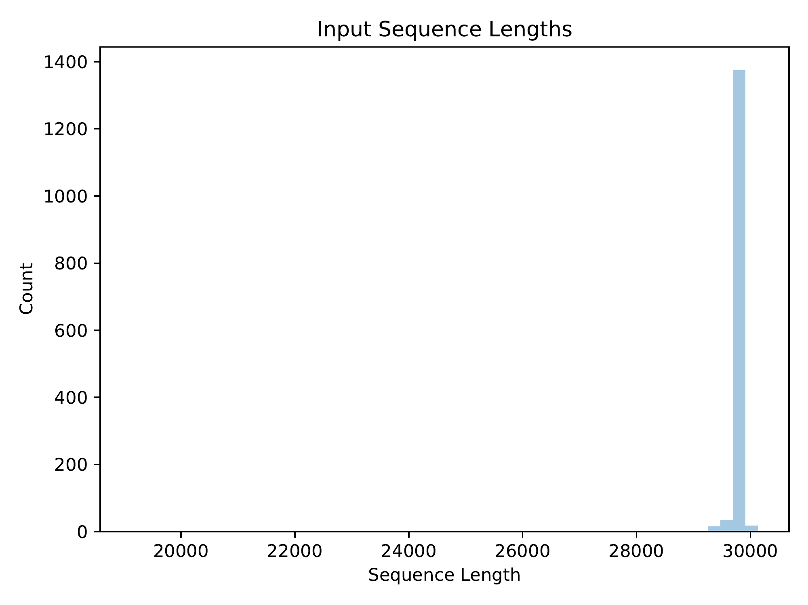

Distribution of input sequence lengths

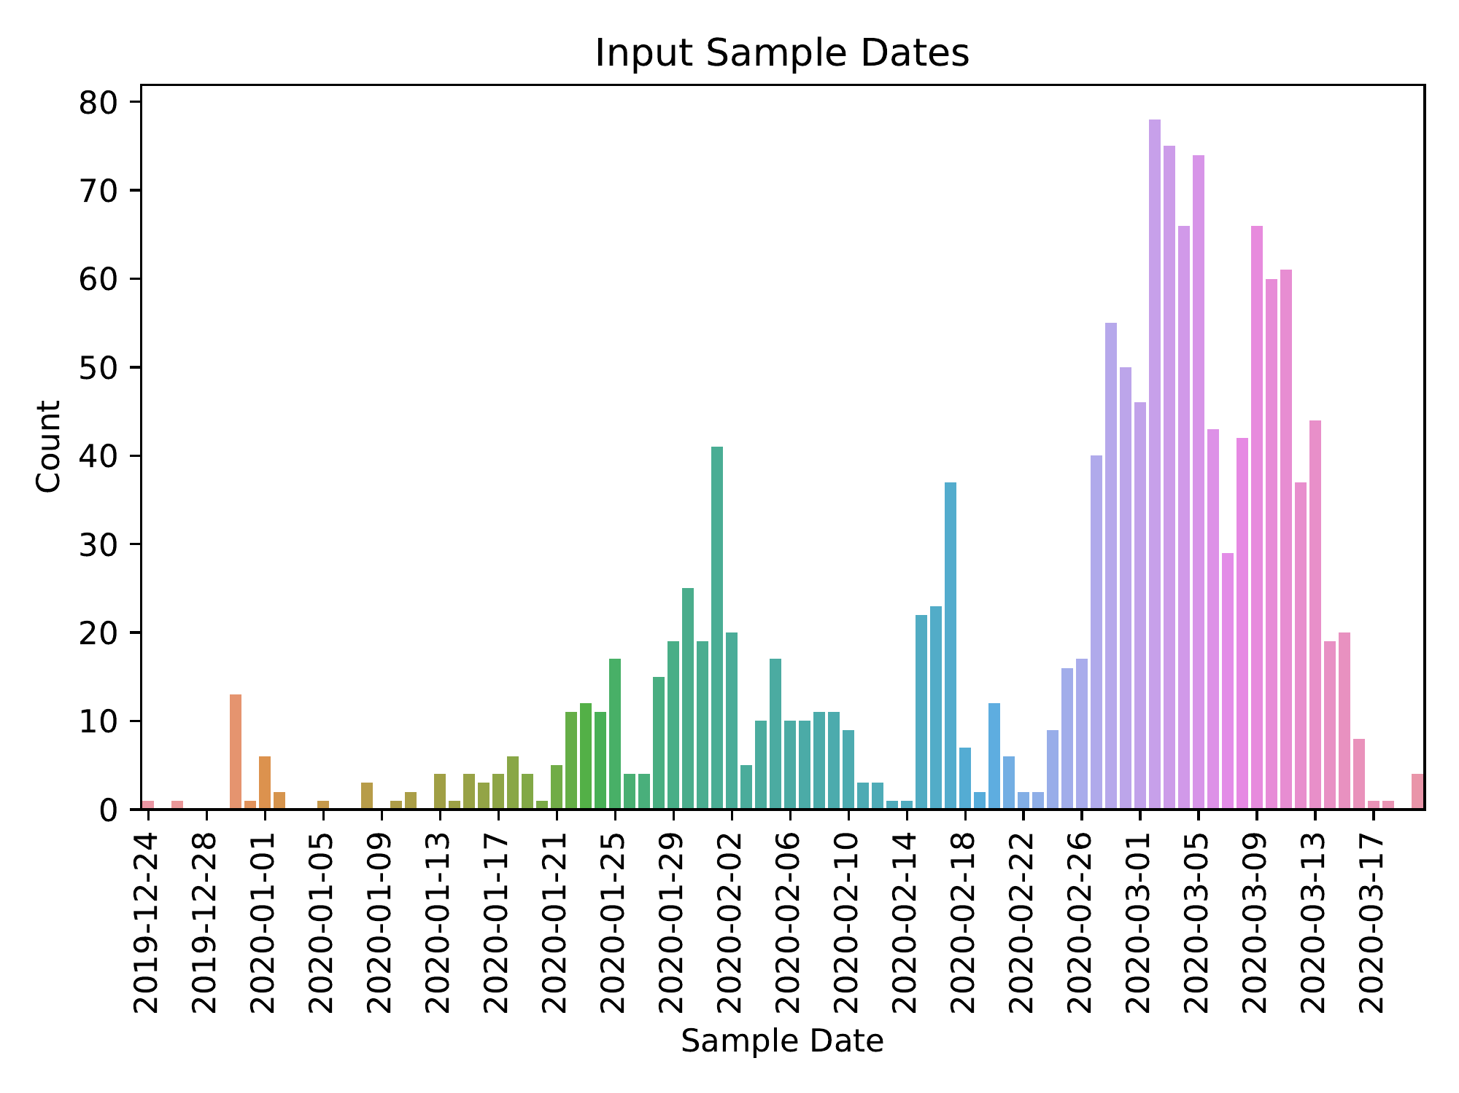

Distribution of input sample dates

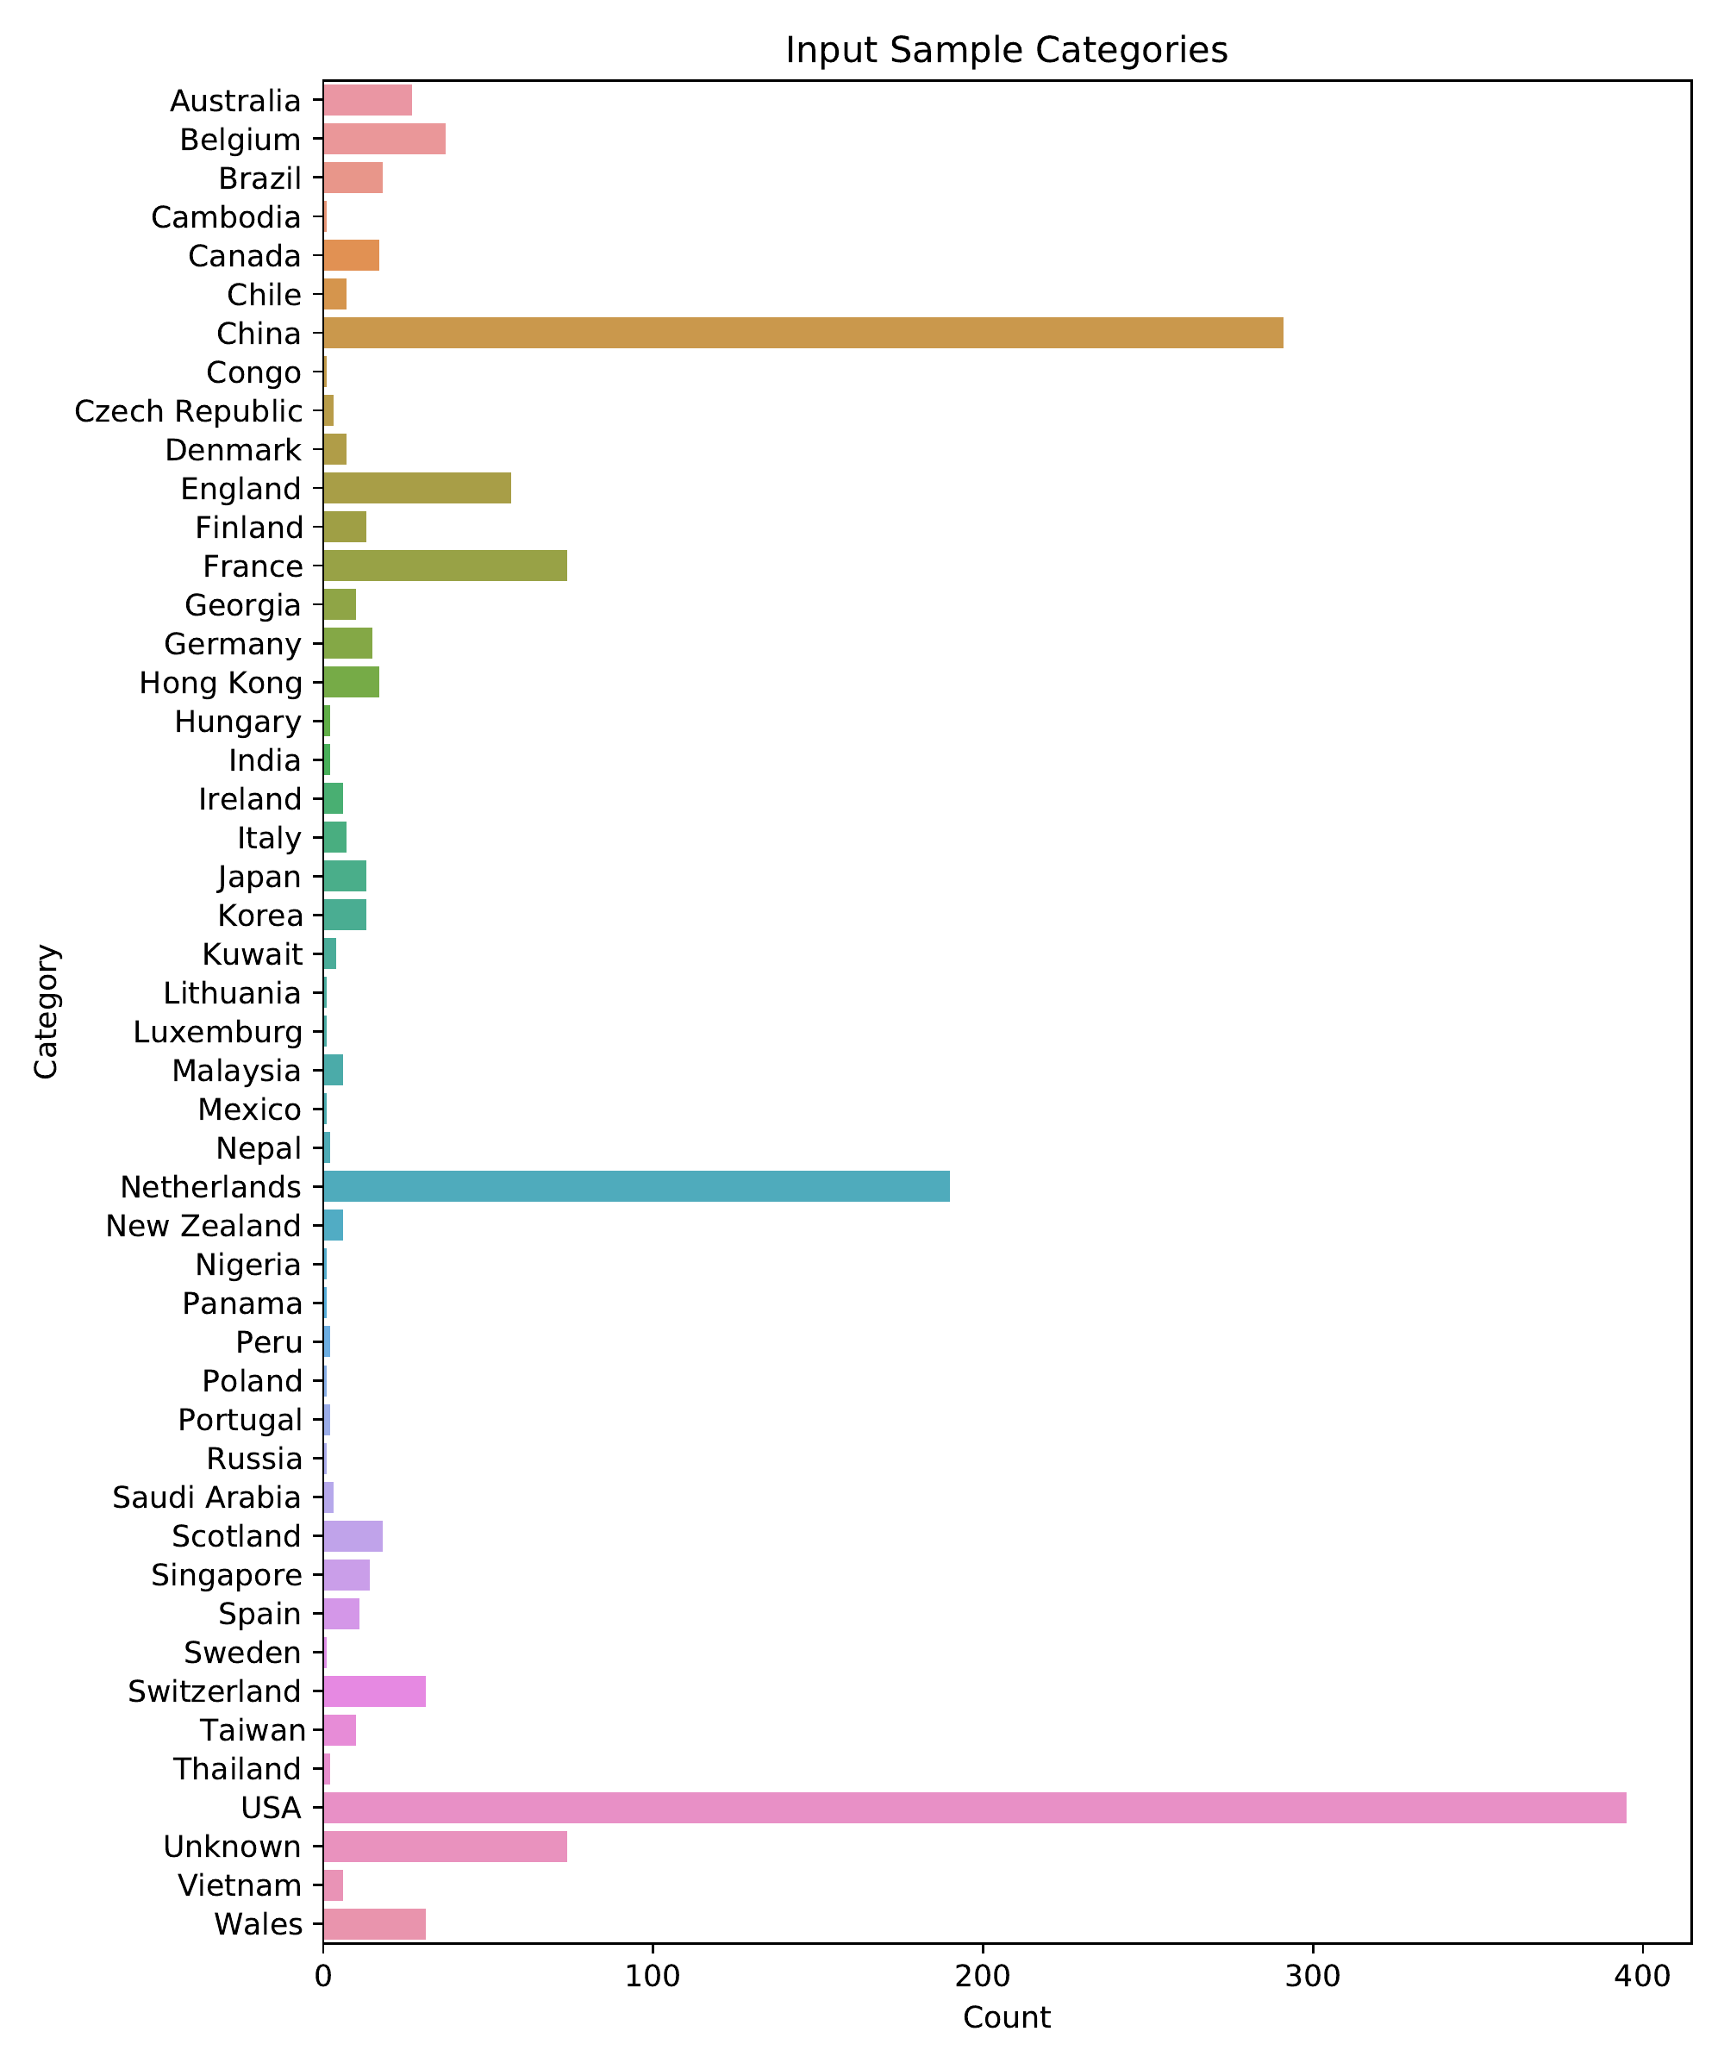

Distribution of input sample categories

# Preprocessed Dataset

The input dataset was preprocessed such that sequences were given safe names: non-letters/digits in sequence IDs were converted to underscores. After preprocessing, the dataset contained 1453 sequences. The average sequence length was 29818.428, with a standard deviation of 345.395. The earliest sample date was 2019-12-24, the median sample date was 2020-03-02, and the most recent sample date was 2020-03-20.

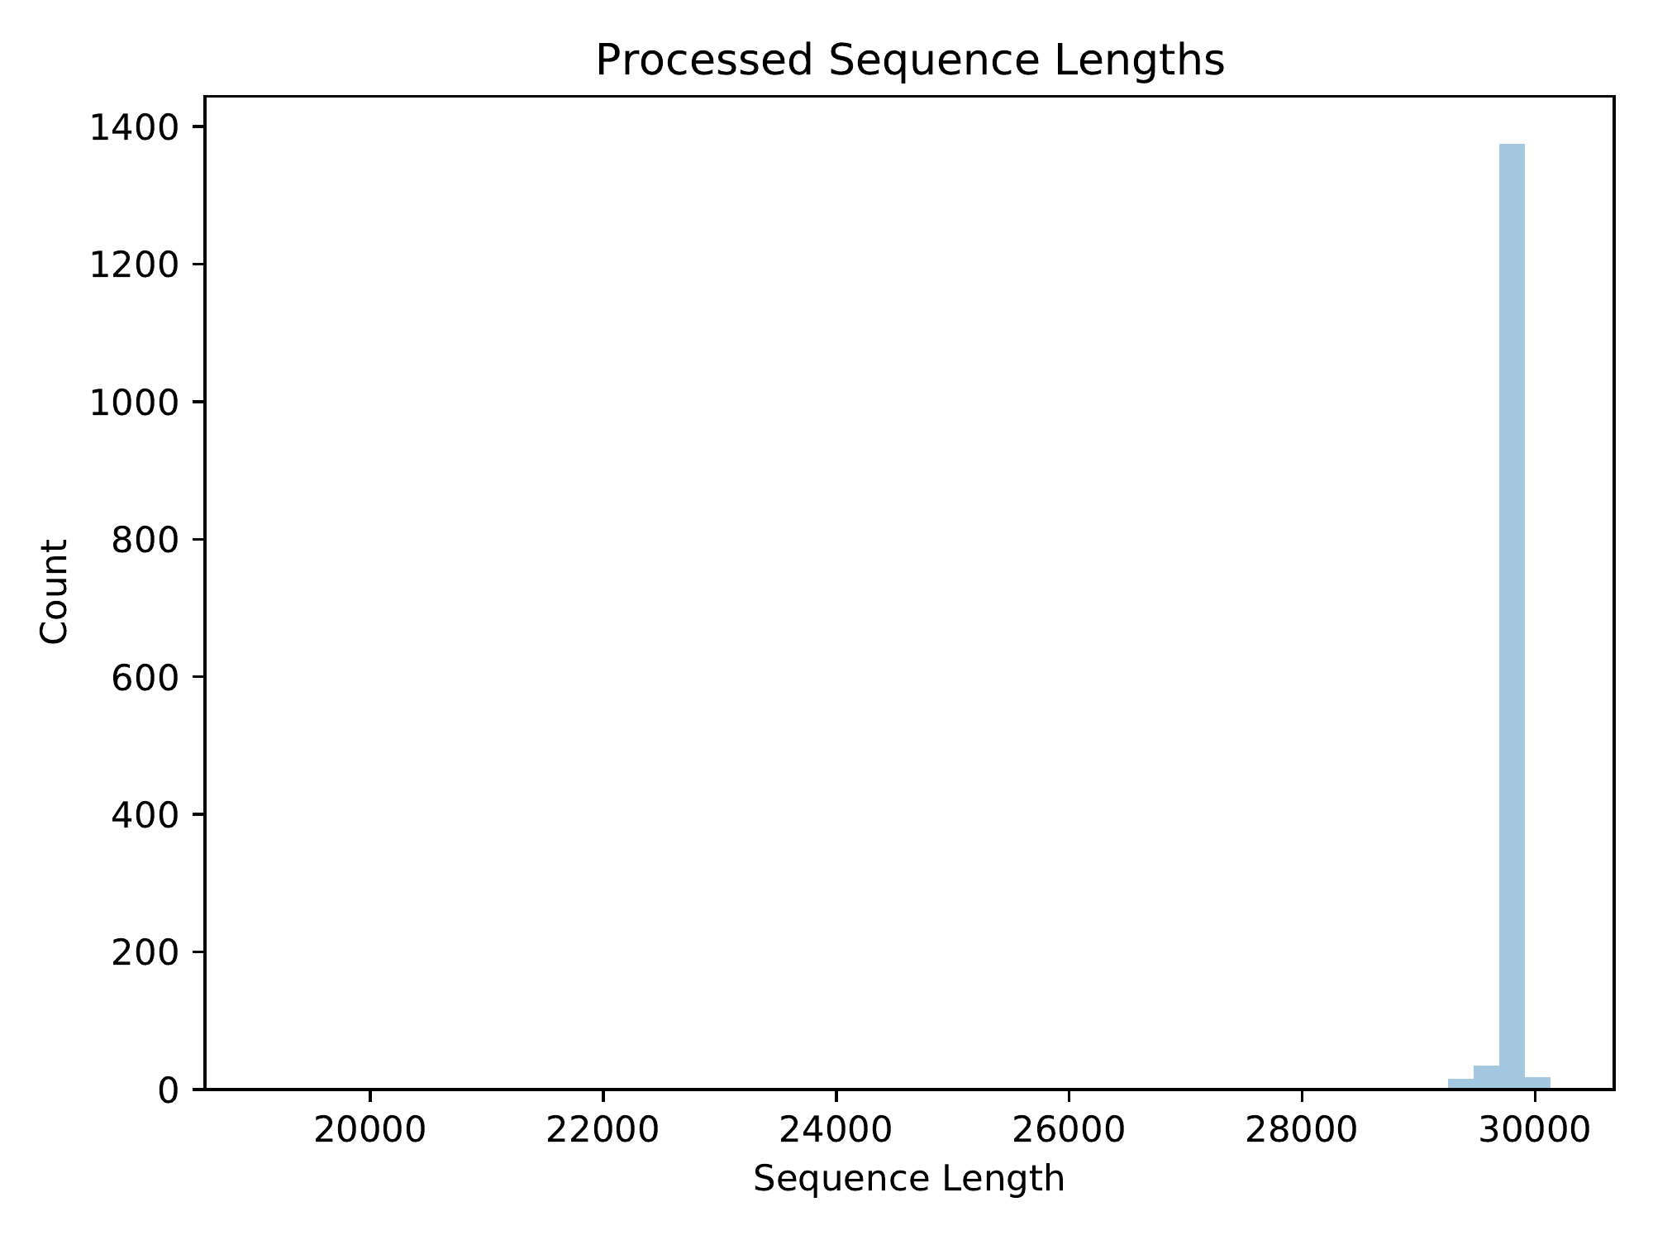

Distribution of preprocessed sequence lengths

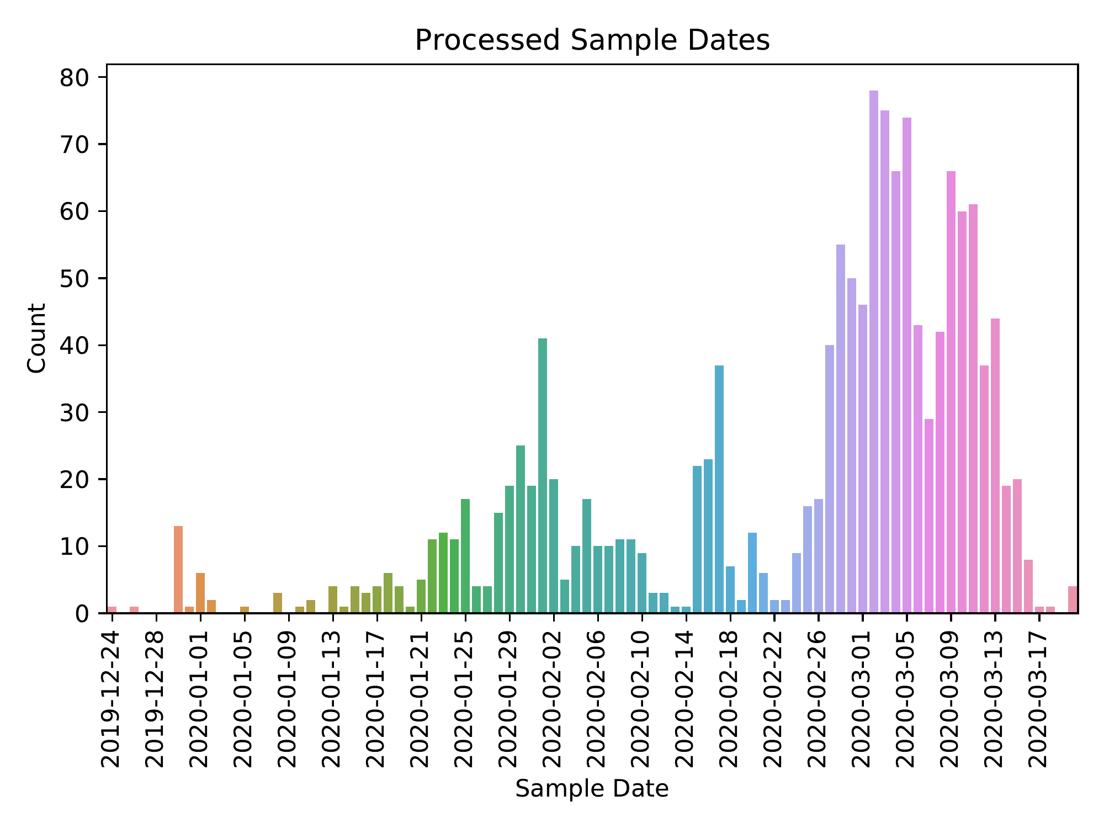

Distribution of preprocessed sample dates

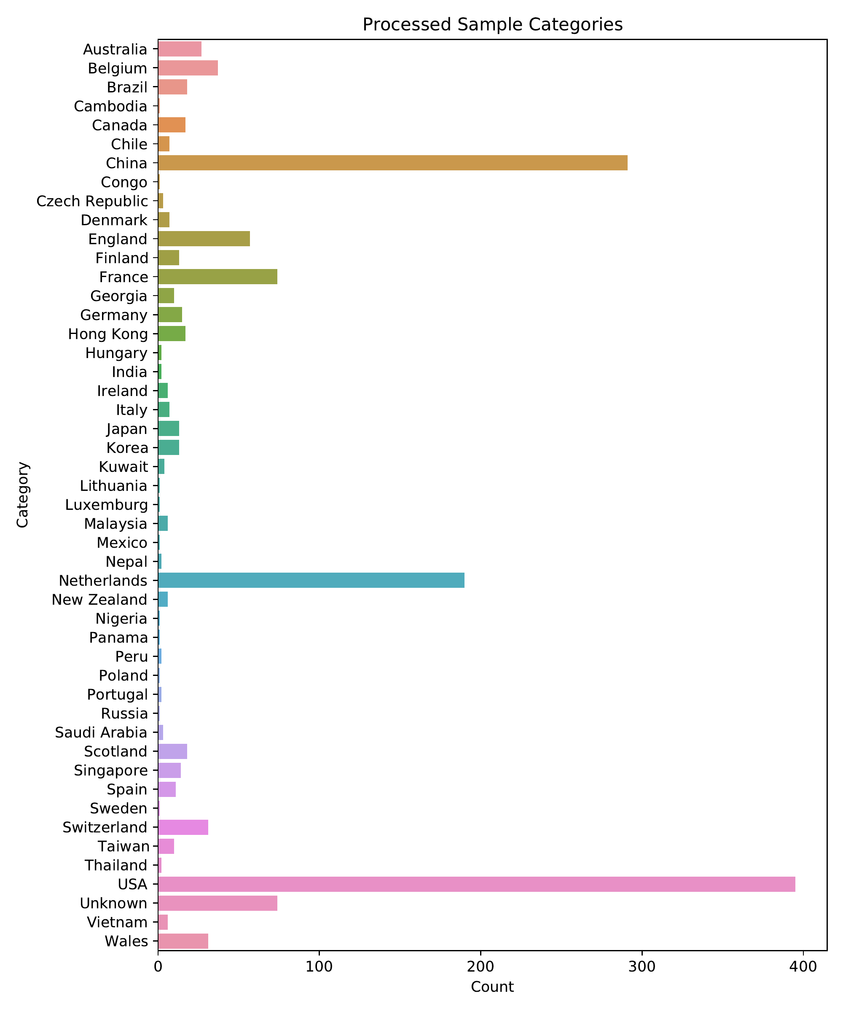

Distribution of preprocessed sample categories

# Multiple Sequence Alignment

Multiple sequence alignment was performed using Minimap2 (Li, 2018). Each input sequence was aligned to the reference sequence (MT072688), and the multiple sequence alignment was constructed based on positions in the reference. There were 29811 positions (3279 invariant) and 1137 unique sequences in the multiple sequence alignment. Pairwise distances were computed from the multiple sequence alignment using the tn93 tool of HIV-TRACE (Pond et al., 2018). The average pairwise sequence distance was 0.000285, with a standard deviation of 0.000135.

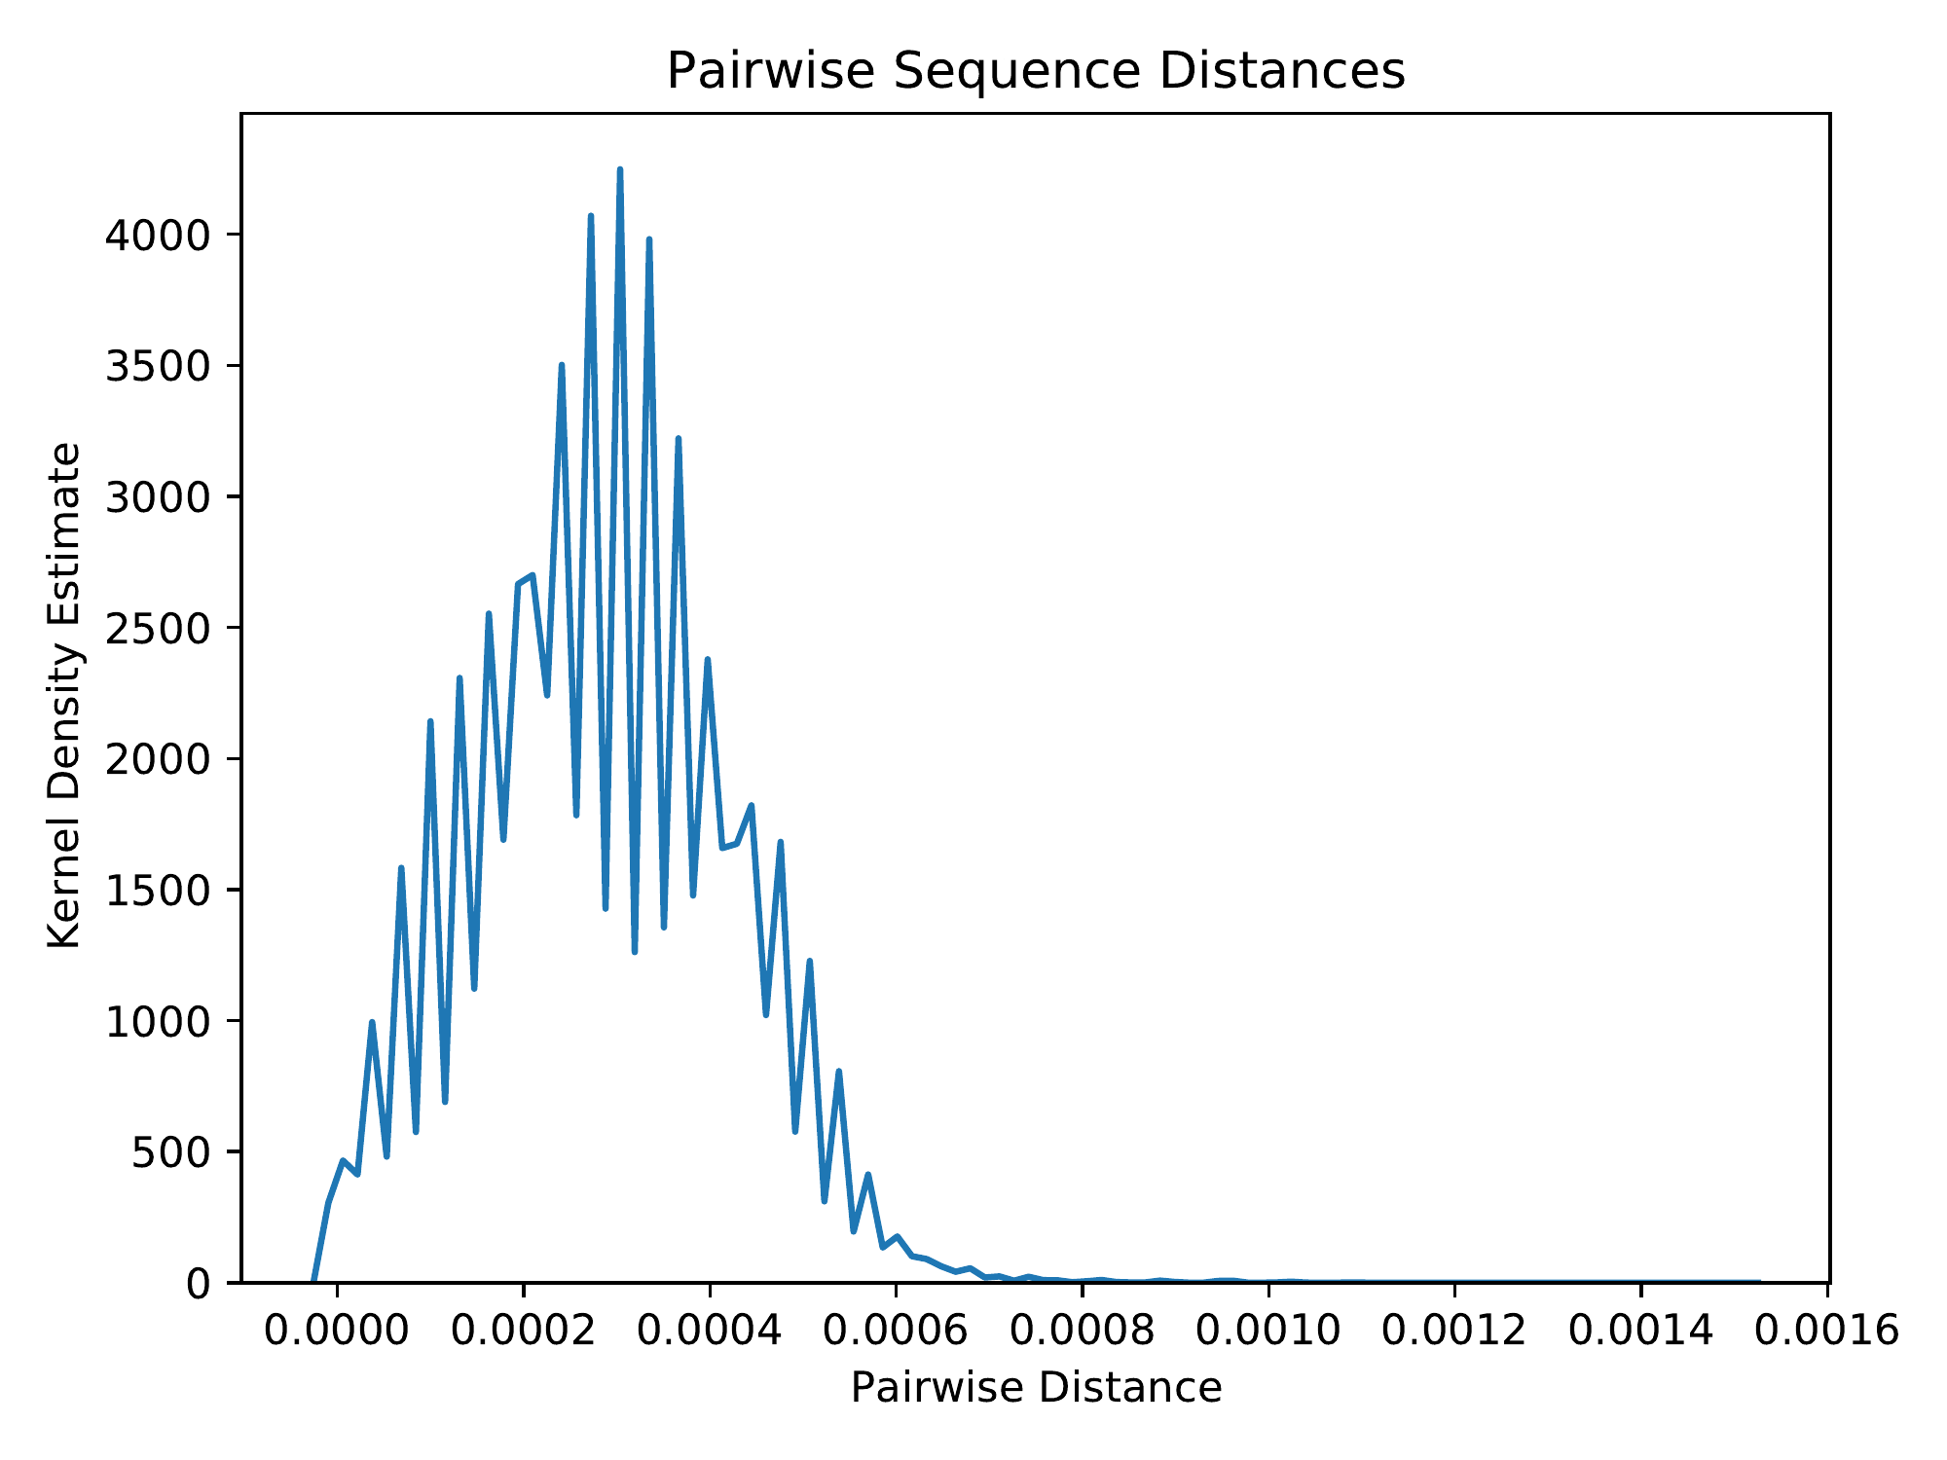

Distribution of pairwise sequence distances

Across the positions of the multiple sequence alignment that had non-zero Shannon entropy, the minimum Shannon entropy was 0.00837, the maximum Shannon entropy was 0.914, and the average Shannon entropy was 0.0238, with a standard deviation of 0.0788.

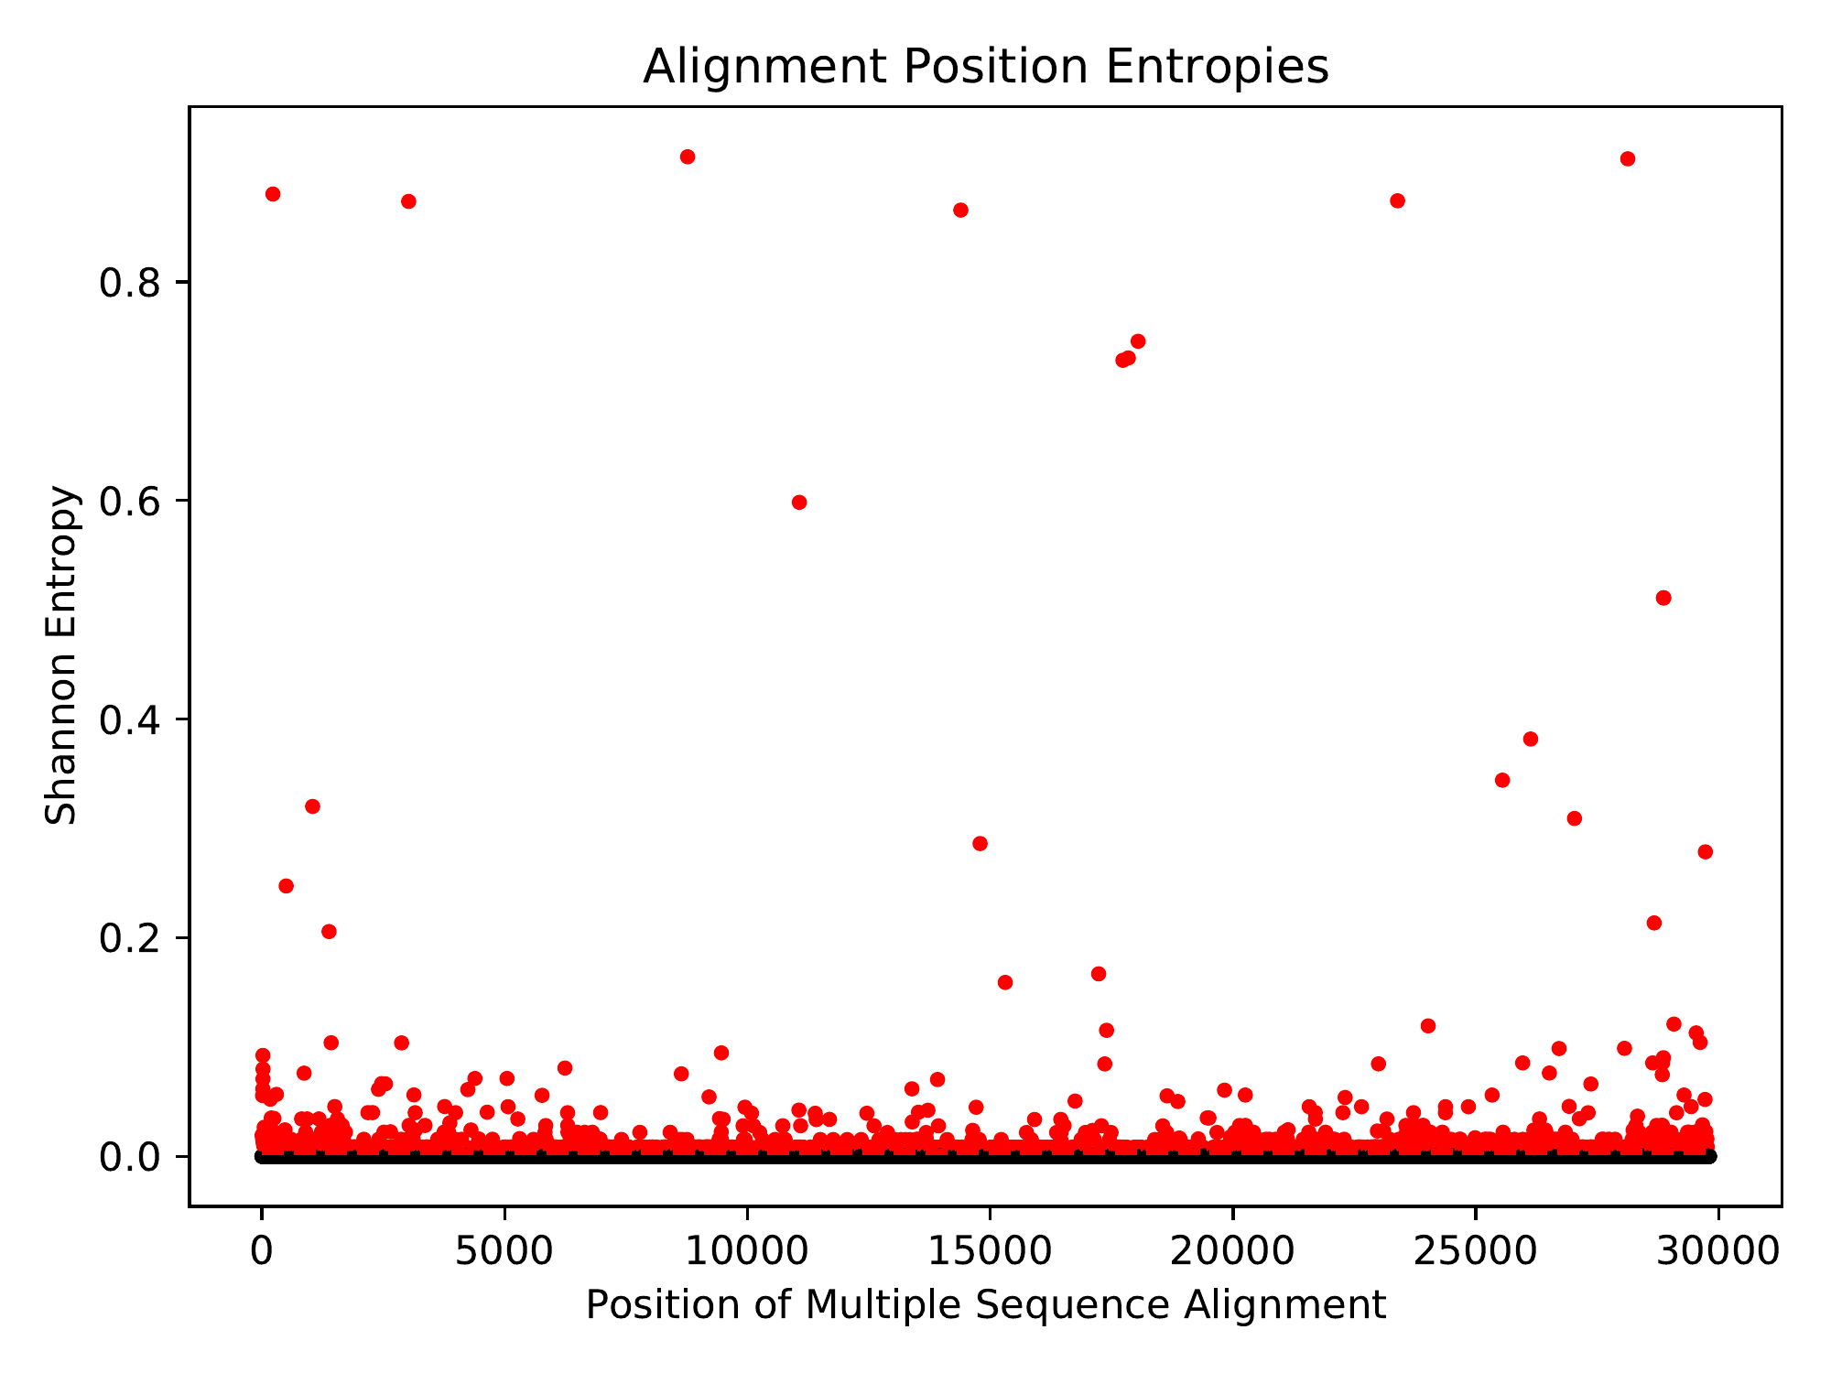

Shannon entropy across the positions of the multiple sequence alignment. Due to the abundance of zero-entropy positions, all non-zero entropies were deemed significant. The significance threshold is shown as a red dashed line, and significant points are shown in red.

# Phylogenetic Inference

A maximum-likelihood phylogeny was inferred under the General Time-Reversible (GTR) model (Tavare, 1986) using FastTree 2 (Price et al., 2010) using a Gamma20-based likelihood. The inferred phylogeny was MinVar-rooted using FastRoot (Mai et al., 2017). Pairwise distances were computed from the phylogeny using TreeSwift (Moshiri, 2020). The maximum pairwise phylogenetic distance (i.e., tree diameter) was 0.00151, and the average pairwise phylogenetic distance was 0.000347, with a standard deviation of 0.000169.



Rooted phylogenetic tree in unit of expected per-site mutations

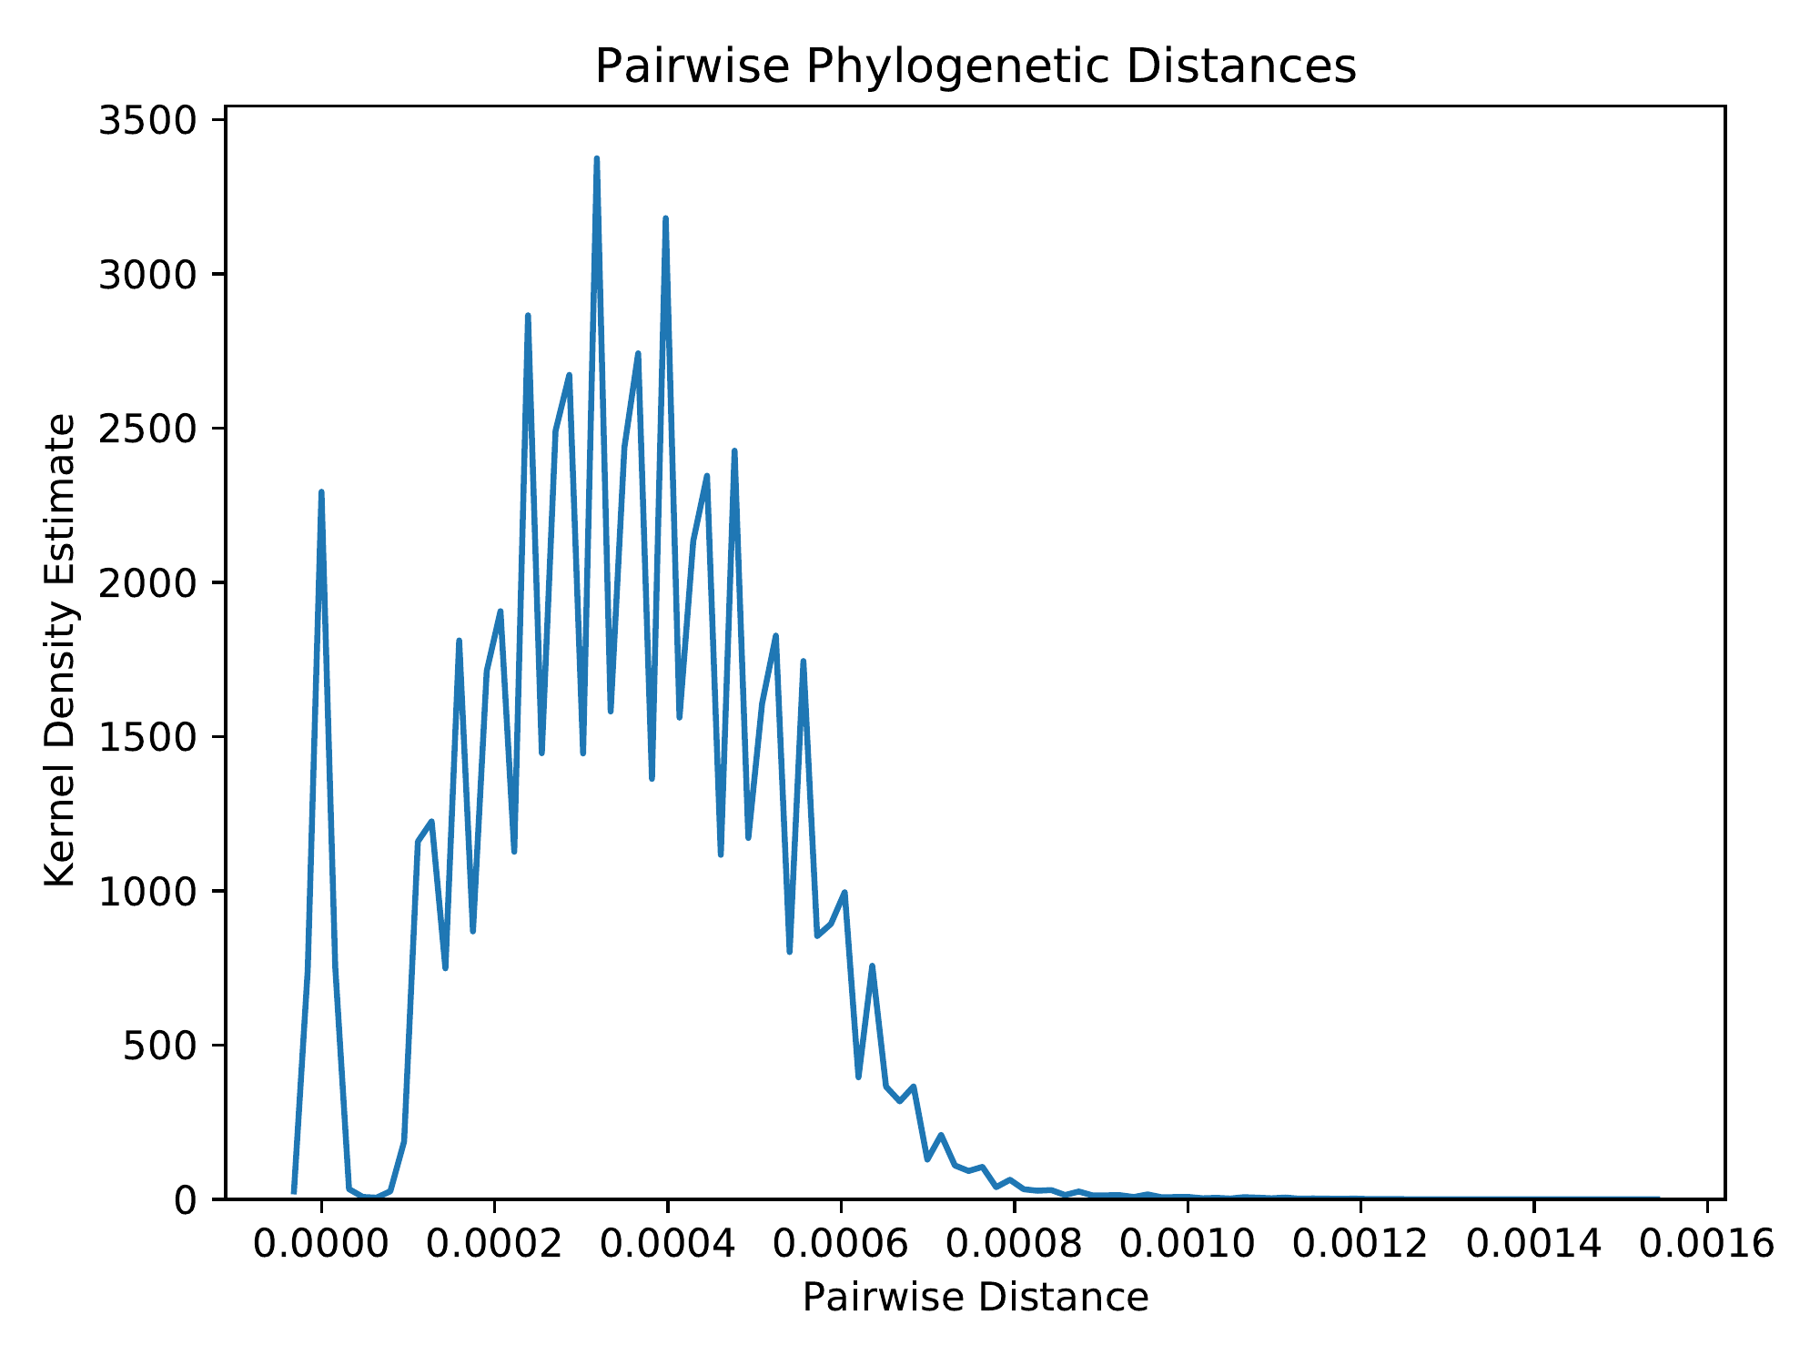

Distribution of pairwise phylogenetic distances

# Phylogenetic Dating

The rooted phylogeny was dated using treedater (Volz & Frost, 2017). The height of the dated tree was 99.806 days, so given that the most recent sample was collected on 2020-03-20, the estimated time of the most recent common ancestor (tMRCA) was 2019-12-11.



Dated phylogenetic tree in unit of years

# Ancestral Sequence Reconstruction

Ancestral sequence reconstruction was performed using TreeTime (Sagulenko et al., 2018).

# Transmission Clustering

Transmission clustering was performed using TreeN93 (Moshiri, 2018) using pairwise phylogenetic distances. The total number of singletons (i.e., non-clustered individuals) was 166, and the total number of clusters (excluding singletons) was 27. The average cluster size (excluding singletons) was 46.667, with a standard deviation of 148.951, and the maximum and minimum cluster sizes were 764 and 2, respectively.

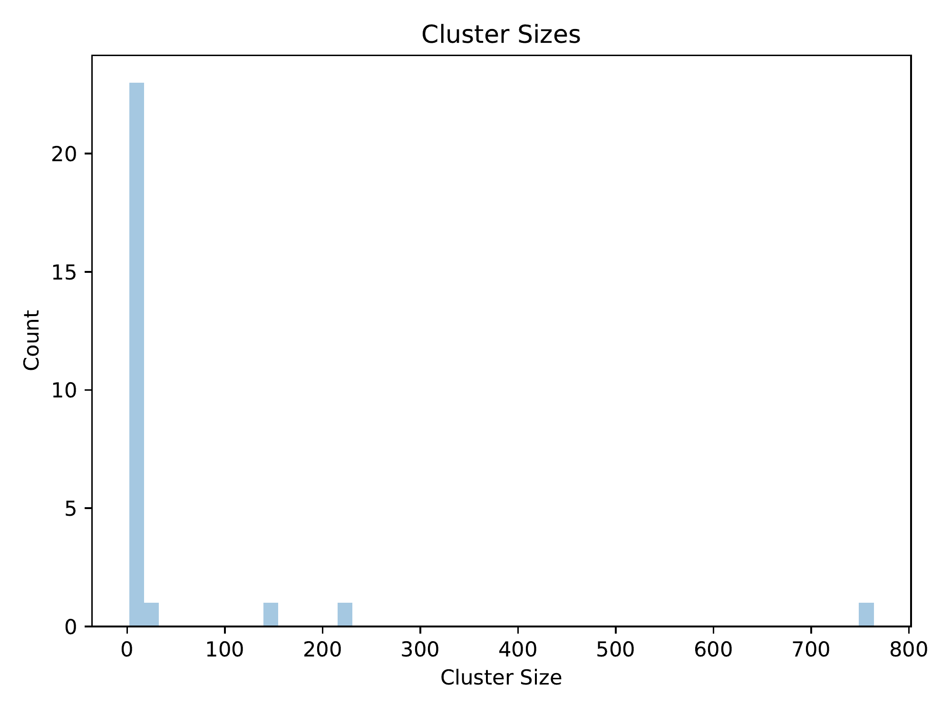

Distribution of cluster sizes (excluding singletons)

# Citations

* Le S.Q., Gascuel O. (2008). "An Improved General Amino Acid Replacement Matrix". Molecular Biology and Evolution. 25(7), 1307-1320.
* Li H. (2018). "Minimap2: pairwise alignment for nucleotide sequences". Bioinformatics. 34(18), 3094-3100.
* Mai U., Sayyari E., Mirarab S. (2017). "Minimum Variance Rooting of Phylogenetic Trees and Implications for Species Tree Reconstruction". PLoS ONE. 12(8), e0182238.
* Moshiri N. (2018). "TreeN93: a non-parametric distance-based method for inferring viral transmission clusters". bioRxiv.
* Moshiri N. (2020). "TreeSwift: a massively scalable Python tree package". SoftwareX. In press.
* Moshiri N. (2020). "ViReport" (https://github.com/niemasd/ViReport).
* Pond S.L.K., Weaver S., Leigh Brown A.J., Wertheim J.O. (2018). "HIV-TRACE (TRAnsmission Cluster Engine): a Tool for Large Scale Molecular Epidemiology of HIV-1 and Other Rapidly Evolving Pathogens". Molecular Biology and Evolution. 35(7), 1812-1819.
* Price M.N., Dehal P.S., Arkin A.P. (2010). "FastTree 2 -- Approximately Maximum-Likelihood Trees for Large Alignments". PLoS ONE. 5(3), e9490.
* Sagulenko P., Puller V., Neher R.A. (2018). "TreeTime: Maximum-likelihood phylodynamic analysis". Virus Evolution. 4(1), vex042.
* Tavare S. (1986). ""Some Probabilistic and Statistical Problems in the Analysis of DNA Sequences". Lectures on Mathematics in the Life Sciences. 17, 57-86.
* Volz E.M., Frost S.D.W. (2017). "Scalable relaxed clock phylogenetic dating". Virus Evolution. 3(2), vex025.